Sprint 2 Report

Decentralized Application Framework (DAPPF)

Kirill, Anthony, Garrett, Shishir, Vincent

11/1/21

**Actions to stop doing:**

* The team should stop holding long meetings and focus more on the Scrum meeting portion.

**Actions to start doing:**

* The team should make sure to update everyone on their progress, and inform the team if they are running into issues.

**Actions to keep doing:**

* The team should continue to schedule meetings between 2pm - 5pm, because we have teammates in other countries, and holding meetings has shown to improve productivity as compared to the previous sprint.
* The team should continue to hold more meetings during the week, because we need to know what portion of code each team member implemented.

**Work completed/not completed:**

* Completed:
  + As a developer, I would like to connect two nodes
  + As a product owner, I would like to secure my user’s data
  + As a developer, I would like to reduce data sent
  + As a developer, I would like access to documentation about the framework
* Not Completed:

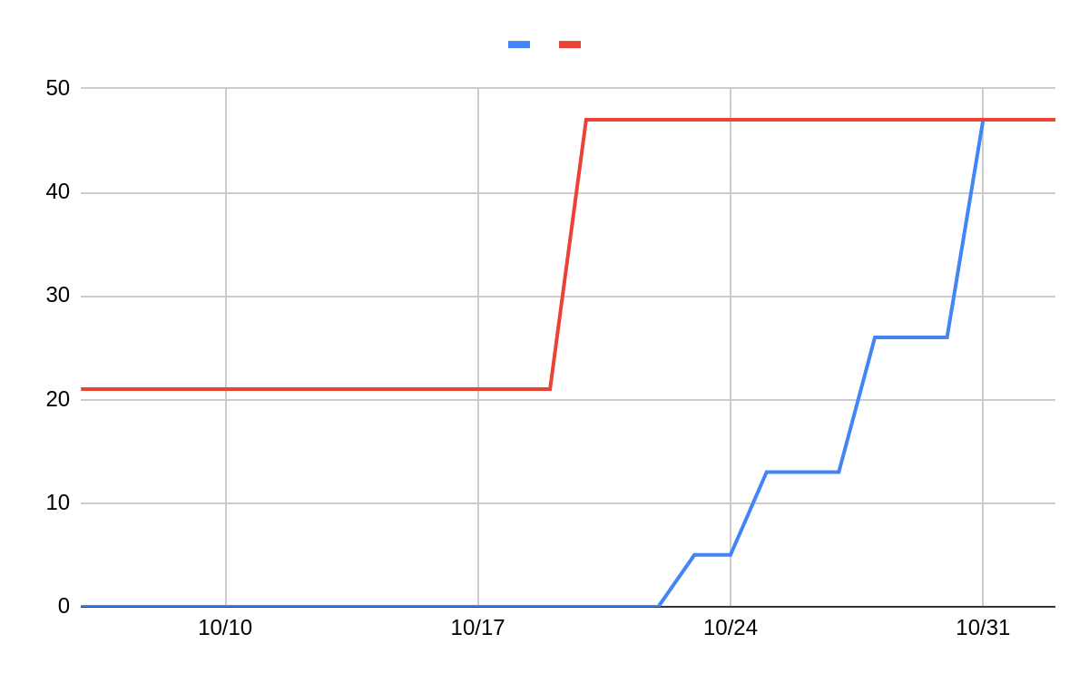

**Work completion rate:**

| **Sprint #** | Sprint 1 | Sprint 2 | **Average** |
| --- | --- | --- | --- |
| **User stories completed** | 0/1 | 4/4 |  |
| **Estimated Work Hours** | 20 | 30 | **25** |
| **Number of days worked** | 8 | 8 | **8** |
| **User Stories/Day** | 0 | 0.5 | **0.25** |
| **Work Hours/Day** | 2.5 | 3.75 | **3.125** |